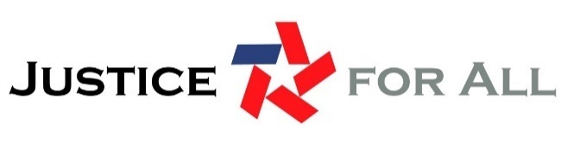
Component Assessment: Stakeholder Capacity & Governance
Key Elements
This assessment is designed to provide insights into the capacity and structure of all stakeholders engaging in the JFA process. Understanding more about the capacities of stakeholders can inform what practical roles they can take in access to justice activities.
Key elements of Stakeholder Capacity & Governance include:
- Established forum and process for collaboration among stakeholder groups;
- Clear understanding of access to justice roles and responsibilities within and among stakeholder groups; and
- Dedicated attention to funding, resources and partnerships to support growing stakeholder and ecosystem capacity.
As this assessment will help identify the optimal role for each stakeholder in the JFA ecosystem approach, these questions should be completed by each stakeholder.

Stakeholder Information
- I am from a:
Court
Bar association
Legal aid organization
Government agency
Non-profit organization
Foundation or philanthropic organization
A different type of organization:

- What is your mission and how does it relate to access to justice?

Stakeholder Structure
- What is your governance structure and how might that impact your involvement in access to justice activities?

- Which of the following activities can you engage in? (select all that apply)
Law reform
Community organizing
Lobbying
Client services
Direct representation in court
Case management
Other (please specify)

- Would you need additional staff to engage in access to justice governance or policy activities or does your current staff already do this work? (select all that apply)
Current staff does this work
Need additional staff
Other (please specify)

Stakeholder Policies, Procedures & Plans
- There are a number of policies, procedures and plans that impact the quality and effectiveness of access to justice work. Please select all that apply or have been adopted by your organization:
Plain language guides and policies
Civil justice communications plan
Language access plan
Legal information and legal advice policies and training
Technology plan
Monitoring and evaluation strategies
Consumer-oriented data policies
User-friendly business practices (e.g., process mapping, simplification strategies, inclusive and participatory design practices)
Other (please specify)

Stakeholder Funding Streams
- What funding streams support your organization. Please check which type of organization you are from, and then check all that apply.
Specific appropriation in state court budget
Specific appropriate in county court budget
IV-D funding
VOCA funding
Other federal funding
Specific state appropriations
Specific county appropriations
Specific city/local appropriations
Dues, members, or licensing fees
Bar foundation
IOLTA
United Way
Other private grants
Public grants
Partnership grants
Venture capital
Angel investors
Filing fees
Fines
Educational institution funding
Fund-raising events
Income from services
Income from workshops
Income from forms
Income from donations
Other (please specify)

Stakeholder Partnerships
- What kind of organizations or entities do you partner with?
Court - clerk’s office
Court - administrative office
Court - judicial officers
Court - IT department
Law enforcement
Domestic violence shelters
Substance abuse treatment providers
Public library
Law library (open to public)
Law library (limited public access)
Legal aid
Human services
Bar association
Access to justice commission
Bar foundation
Law school-clinic
Law school-professors
Colleges and universities
Community colleges
Hospitals
Private industry
Banks & credit unions
Chambers of commerce
Technologists
Legislative branch staff
Executive branch staff
First responders
Social workers
Teachers
School nurses
Workforce development staff
Mental health providers
Disability advocates
Consumer advocates
Veterans’ advocates
Aging & elders advocates
Interpreters
Immigration/refugee services
Homeless services
Religious leaders service organizations (rotary, lions, elks, etc.)
Other (please specify)

