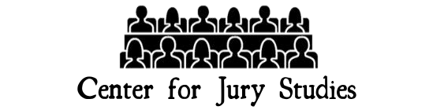

G. Thomas Munsterman Award Submission Form
Please use this form to nominate a candidate for the 2022 G. Thomas Munsterman Award.

Please identify your name and contact information.

Please identify the state, local court, individual or organization you are nominating.

What specifically has this person or entity done to make significant improvements or innovations in jury procedures, operations, or practices in one of the following categories:
- state or local statutes, rules, or other formal changes
- jury management or technology
- in-court improvements
- other improvements or innovations

What were the impacts of the improvements or innovations? (Be sure to identify fiscal impacts in as much detail as possible if there were any)

Have the improvements or innovations been recognized formally by any other groups or informally by the media?

Please provide information about the timeframe of when the improvements or innovations occurred.

Tell us anything else that you think is relevant for the judges to consider.

You may also attach any photographs, videos, letters of support or other documentation to support your nomination. (Letters of support may be submitted directly to Greg Mize following your submission.) Please submit all other documents (if any) along with this form to Greg Mize at gmize@ncsc.org by September 2, 2022.

